American Stampless Catalog 2016 Pre-Release Listing
Key (YEAR-YR, cancel type(O=circle/oval)-mm size, mark, color)
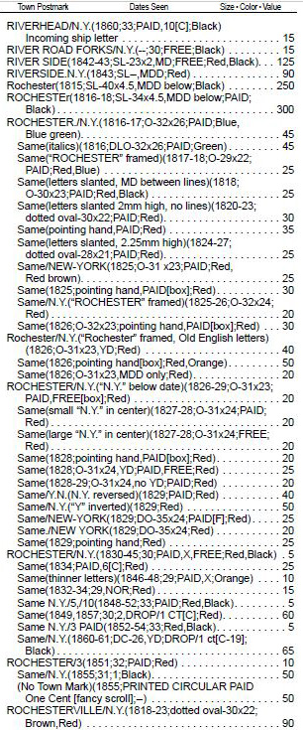

1
2

3

4
5

6

7

8
9

10

11
12

13
14

15
16
17

18

19

20
21
22
23
24
25
26
27
28
29
30
31
32
33
34
35

36
37
38

V1

